# ASSIGNMENT #3

Due Date: 7/11/2023 (at 23.55)

**Question #1**

Given is the following program

void main ()

{

1. int n,x,y,i,flag, a;
2. cin >> a; // input a
3. cin >> x ; // input x
4. cin >> y; // input y
5. cin >> n  ; // input n
6. i=3;
7. flag = 1;

C1 C2 C3

1. while ((i < n) || ((flag <= 0)&& (a!=y)))

{

1. a++;
2. y=a;

// C4

1. if ((a = =y)) then

12. {flag= 2;}

13. else

14. {flag = 2};

15. i=i+1;

16. }

// C6 C7

17. if ((n > i) && (flag == 0))

18. {cout << “We did not find anything”;} // output

}

1. Create a flow diagram and perform branch testing – provide test cases and indicate clearly which statements/branches are covered by your test bases - below an example of a flow diagram. **If a statement/branch/condition cannot be covered by your test case, clearly state which statement/branch/condition and why!**

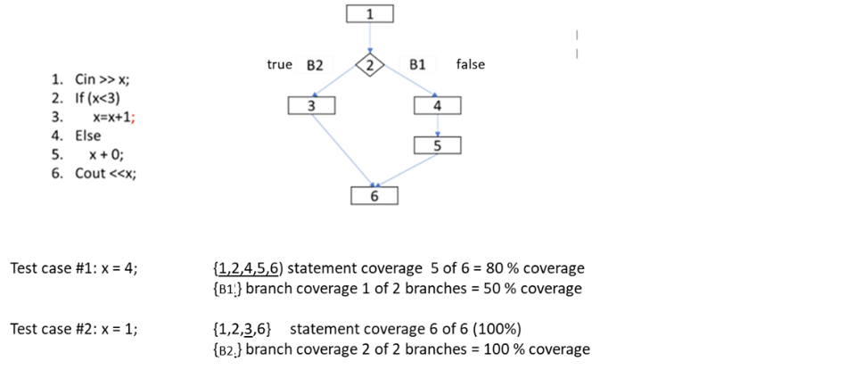

1. Perform multiple condition testing for the program in Question #1. Test cases should be presented as follows.

**Question #2**

Given is the following statement: your new boss states the following: “Given that our organization is using a test-driven development approach, where we write black-box test cases prior to developing our software, there is no more need for white-box testing at the statement coverage criteria, since all the black-box test cases will automatically exercise all statements.

Do you agree/disagree with the statement?

Briefly justify your answer (1-2 sentences).